# STORE MANAGEMENT

## **INTRODUCTION**

* 1. **PURPOSE**

Our product is store management system gives all the services that must be provided to a store which keeps the records of all the details of the products in the store.

This product contains each and every data regarding buying, adding, removing a new product from the store. It provides information on the stock available in the store. It also updates the stock and displays it.

* 1. **AUDIENCE AND READING SUGGESTIONS INTENDED**

## The intended audience for this Student Management System document is the internal guides of the organization where the team has developed the project. Further modifications and reviewing will be done by the organization and deliver a final version. The final version of this document is reviewed by the Internal Guides and Head of the Department of the college.

* 1. **PROJECT SCOPE**

Our Store Management System product usage makes work done faster way. The user can edit the products, buy products etc by using these software.

## **OVERALL DESCRIPTION**

**2.1 PROJECT FEATURES**

* Reduces the manual workload.
* Complete details of the products can be stored and retrieved.
* Admin(Employee) can add, remove, view capacity of the items in the store.
* Protected from outside world by password protection.

**SOFTWARE REQUIREMENTS**

* Compilers like Visual C++, Dev C++ etc.

**HARDWARE REQUIREMENTS**

* Processor: Intel Pentium 4 or more
* RAM: 1 GB or more
* Hard disk: 40 GB hard disk recommended for the primary partition

## **SYSTEM FEATURES**

This Store Management System project is divided into 2 Modules.

1. Administrator
2. User

**Module description**

**Admi**n: Admin is a person whose responsibility is to maintain the database that contains each and every data regarding all the products in the store. Admin can add products into the database, can be able to delete products and can update other information.

In these project there are 2 admins

1. Dealer
2. Employee

**User**: Here the user means Consumer. The consumer can view the products available, enter the no of products wanted and buy them.

## **ALGORITHM**

1. Start

2. Display Menu for Consumer, Dealer and Employee

2.1If Dealer is selected

2.1.1Ask for password

if password is correct than

* + - 1. Menu to display products, Refill, Add new products

Else

Display authentication failed

2.2if consumer is selected

2.2.1Display menu to purchase product, view the products available

2.3if employee is selected

2.3.1Ask for password

If password is correct than

* + - 1. Menu to display and refill the stock

Else

Display authentication failed

3 Stop

## **OUTPUT**

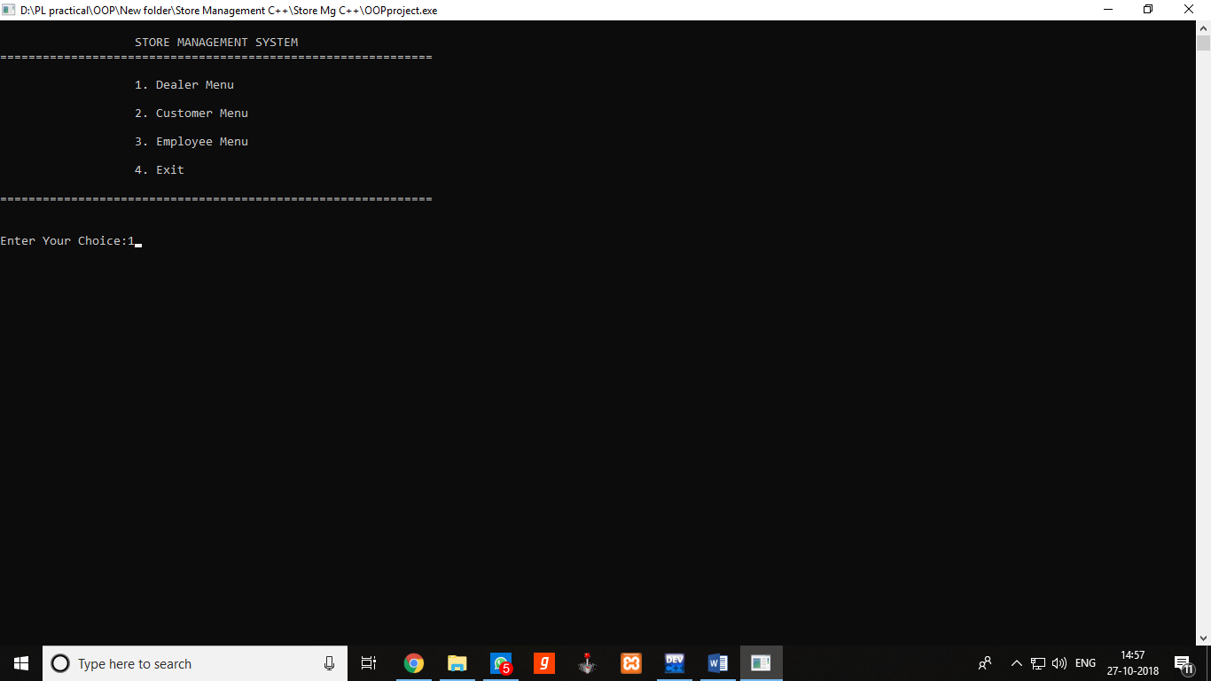

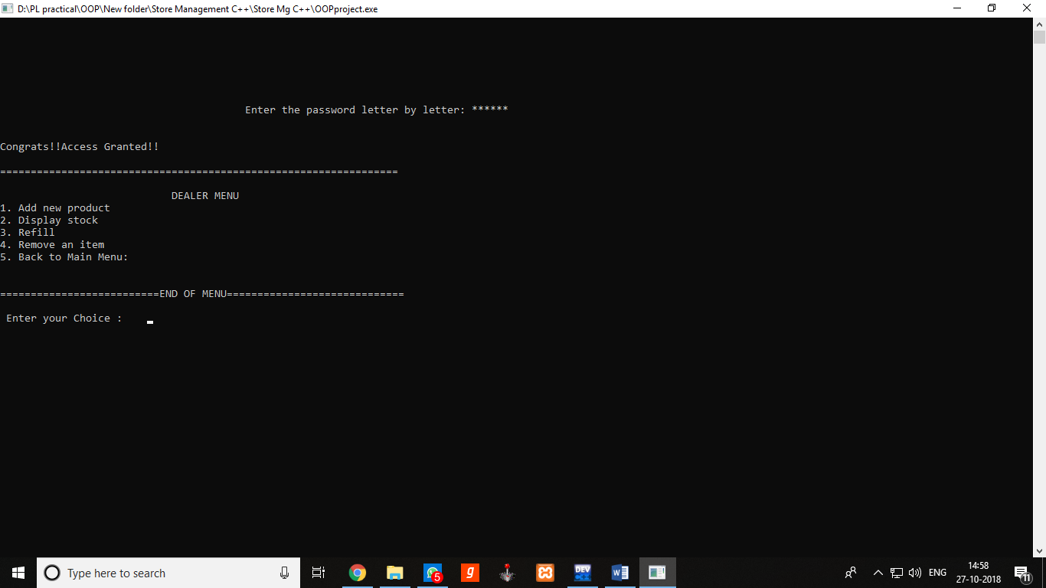

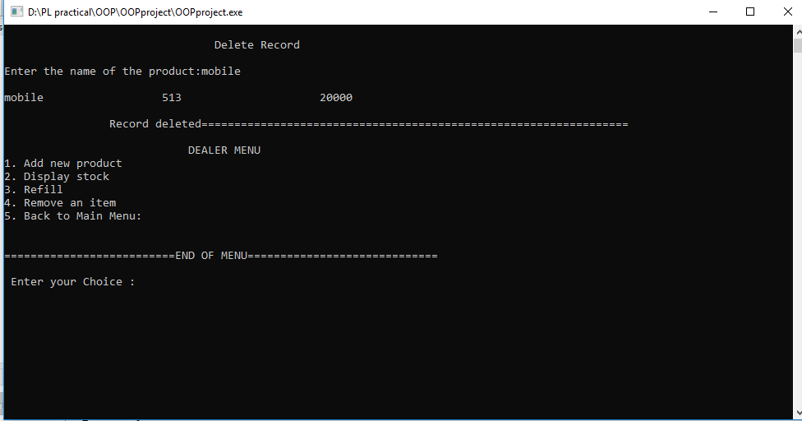

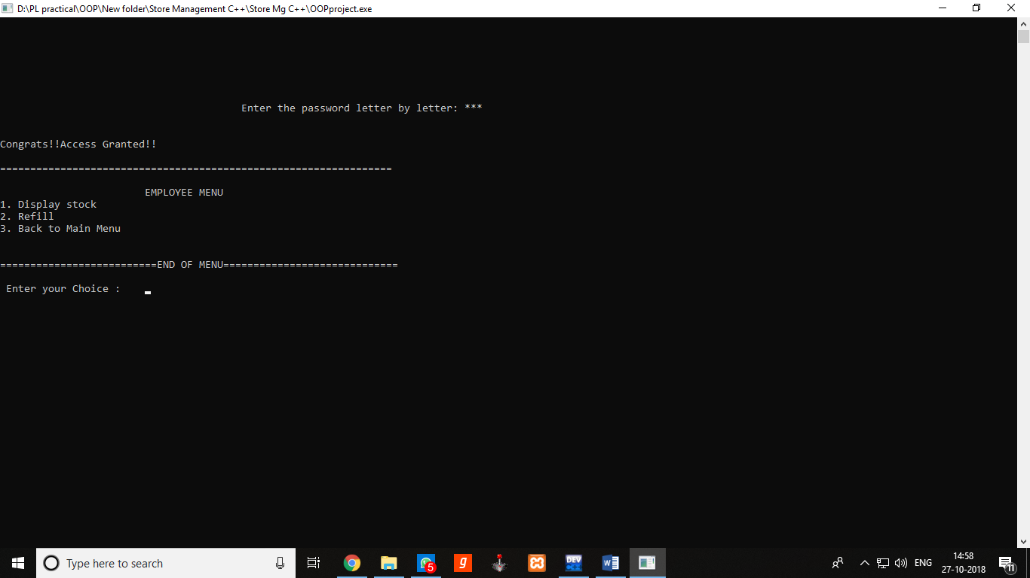

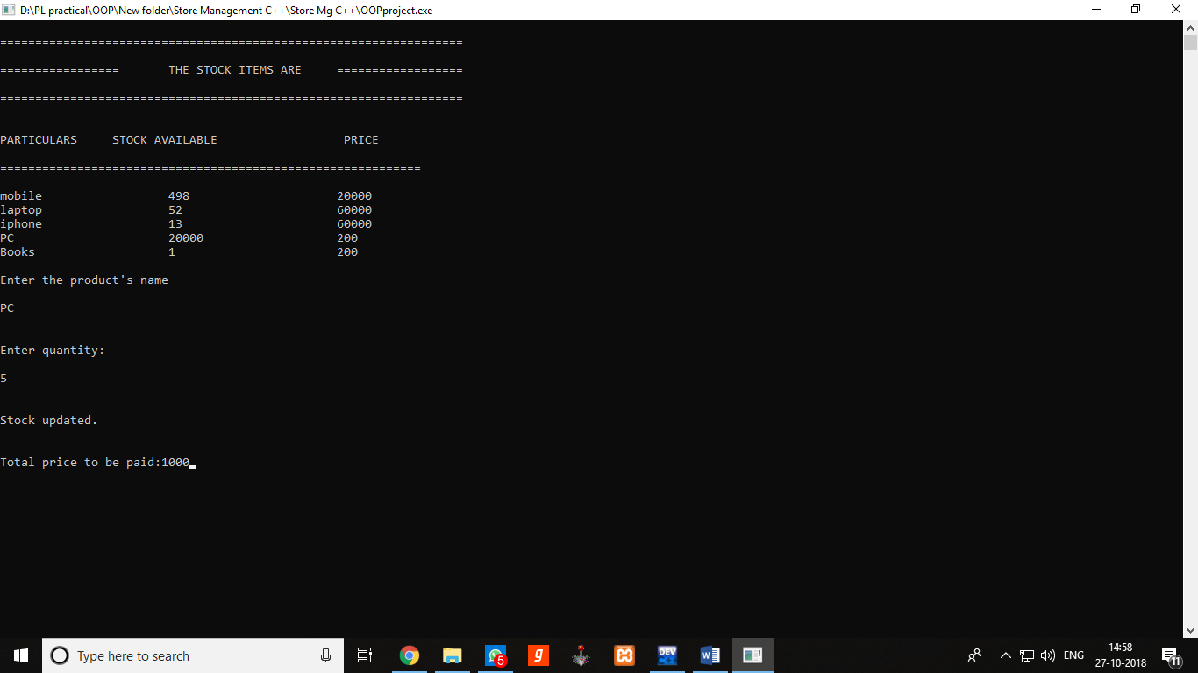

## **CONCLUSION**

An efficient, time saving project for Store Management System was implemented, debugged and executed succesfully

## **ANALYSIS**

**ADVANTAGES**

* **Reduces a lot of manual work in Store**
* **Uses Binary files to store data and hence the code is very much efficient**
* **Contains password protection and hence is protected from outside world**

**PROJECT MEMBERS**

1. **Varun Naik**
2. **Kulbhushan Kelkar**
3. **Lyron Aguiar**

## 